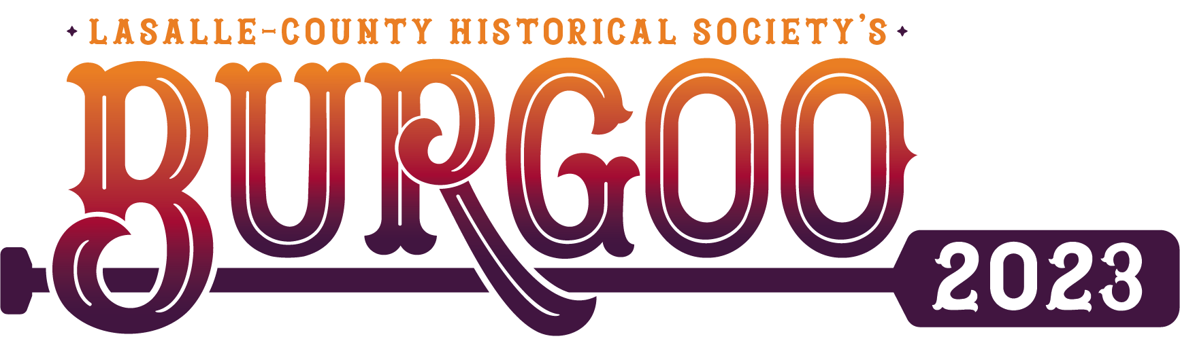

Assigned Vendor Booth #: ____________________

Dear Accepted Sunday Vendor,
Welcome to our 53rd Annual Burgoo Festival, scheduled to take place October 8, 2023! Please review the following information carefully in order to comply with Burgoo Staff instructions, which are designed to prevent congestion and confusion.

Check-in
To ensure a smooth set-up, we have included a map on the back of your parking pass.
All new vendors are required to check in. Check-in will be located at the corner of East Grove Street and Mill Street. If you are a returning vendor and you know where your spot is located, you may bypass this check-in. Burgoo Staff will direct you to your section. From there, you will be directed to your exact booth location. To ensure a smooth set-up, we have included a map on the back of your parking pass.

Please follow the signs to your section. All streets are one-way. Your Vendor Permit must be displayed at all times.
Set-up Details
- You may set-up between 6:00am and 9am on Sunday.
- Bring this letter with you as proof of acceptance & space assignment.
- Verify that you are setting up in the correct space. If you are feeling unsure, please simply ask Burgoo Staff for assistance.
- To avoid blocking traffic, unload and move your vehicle before setting up your stand.
- Vendor booths will be inspected to verify that the merchandise for sale matches information provided on the application and fits within the Historical Society’s criteria.
- Vendors are responsible for the collection & remittance of sales tax. The Illinois Department of Revenue requires that LCHS provide the names of vendors who set-up on Burgoo weekend. We are including the special events tax payment form with this letter, and it will be available on our website as well under Burgoo. If you have any tax-related questions, please contact the Illinois Department of Revenue directly at 847-294-4475.
Vendor Parking & Street Closings
- Vendor Parking is provided because no vehicles are allowed at vendor site(s)
- Parking maps are on the back of your parking pass. Burgoo staff can help direct you to the appropriate parking location.
- No parking is allowed on residents’ driveways or lots without expressed permission.
- ABSOLUTELY NO VENDOR PARKING AT PAID AND VOLUNTEER PARKING AREAS!!!!!!
- The Historical Society will not be responsible for towed vehicles.
- Village officials will begin closing downtown streets on Friday October 7. Our street-closing permit extends from 6am to 5pm on Sunday, October 9.
- Vehicles are not allowed on the streets between 9am and 5pm on Sunday, October 13.
Tear Down
Vendors are responsible for gathering garbage in and around their booth space and placing it in the garbage cans. Cardboard boxes must be broken down and disposed of!
Vendors must be torn down & packed up before bringing their vehicles on site. Please avoid blocking other vendors.
Finally, thank you! The Historical Society will again be providing food and refreshments, most famously our Burgoo Stew. We expect this year to be a good time with the Saturday Car Show and top-notch live entertainment on both days. This will also be our ninth year for the 50/50 Raffle drawing, for which we hope to surpass 2021 winnings exceeding $9,000 for a single winner! Best wishes to you for a successful weekend!
Amanda Carter
Museum Director
LaSalle County Historical Society

