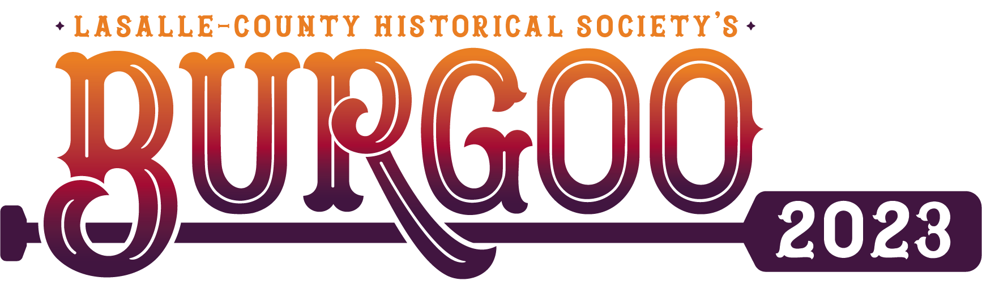

Assigned Vendor Booth #: ____________________

Dear Accepted Saturday and Sunday Vendor,
Welcome to our 53rd Annual Burgoo Festival, scheduled to take place October 7 - 8, 2023! Please review the following information carefully in order to comply with Burgoo Staff instructions, which are designed to prevent congestion and confusion.

Check-in
Check-in will be located at the corner of West Canal Street and Rt. 178. New vendors are required to check in here. To enter the check-in please turn west on West Church Street and follow signs down Division Street to West Canal Street (248 West Canal Street can be added into GPS). From here we will direct you to your vendor space. If you are a returning Vendor and know your location, you may bypass check in and follow signs to your designated vendor space.
PLEASE FOLLOW ALL SIGNS AND BURGOO CREW DIRECTIONS TO AVOID TRAFFIC CONGESTION.

Set-up Times
NOTE: THERE IS NO EARLY SET_UP ON FRIDAY OCTOBER 7
Friday, Oct 7 - 5pm to 7pm (NO SET UP AVAILABLE FOR SECTIONS C AND D ON FRIDAY)
Saturday, Oct 8 - 8am to 10am
Sunday, Oct 9 - 6am to 8am
Set-up Details
- Bring this letter with you as proof of acceptance & space assignment.
- Verify that you are setting up in the correct space. If you are feeling unsure, please simply ask Burgoo Staff for assistance. Burgoo Staff will be in Orange Burgoo Crew shirts.
- To avoid blocking traffic, unload and move your vehicle before setting up your stand.
- Please note that your Vendor Permit must be displayed at all times.
- Vendor booths will be inspected to verify that the merchandise for sale matches information provided on the application and fits within the Historical Society’s criteria.
- Vendors are responsible for the collection & remittance of sales tax. The Illinois Department of Revenue requires LCHS to provide the names of vendors who set-up on Burgoo weekend. We are including the special events tax payment form with this letter, and it will be available on our website (www.lasallecountyhistoricalsociety.org) under the Burgoo tab. If you have any tax-related questions, please contact the Illinois Department of Revenue directly at 847-294-4475.
Vendor WIFI Available
- Wifi is available to vendors in sections K, L, and M
- Wifi is under the name Canal Market and the password is LCHSmarket20
Vendor Parking & Street Closings
- Vendor Parking is provided because no vehicles are allowed at vendor site(s)
- Parking maps are on the back of your parking pass. Burgoo staff can help direct you to the appropriate parking location.
- No parking is allowed on residents’ driveways or lots without expressed permission.
- ABSOLUTELY NO VENDOR PARKING AT PAID AND VOLUNTEER PARKING AREAS!!!!!!
- The Historical Society will not be responsible for towed vehicles
- Village officials will begin closing downtown streets on Friday October 7. Our street-closing permit extends til 5pm on Sunday, October 9.
Tear Down
Vendors are responsible for gathering garbage in and around their booth space and placing it near the garbage cans. Cardboard boxes must be broken down and disposed of!
Vendors must be torn down & packed up before bringing their vehicles on site. Please avoid blocking other vendors.
Finally, thank you for participating two days in our Burgoo Festival! The Historical Society will again be providing food and refreshments, most famously our Burgoo Stew. We expect this year to be a good time with the Saturday Car Show and top-notch live entertainment on both days. This will also be our ninth year for the 50/50 Raffle drawing, for which we hope to surpass last years’ winnings exceeding $9,000 for a single winner!
Best wishes to you for a successful weekend!
Amanda Carter
Events Coordinator
LaSalle County Historical Society

